**Lab-1: Basic Linux Commands**

**Objectives:**

The objective of this exercise is to familiarize users with basic Linux commands and their functionalities. By following the steps, users learn how to navigate the file system, manage directories and files, and utilize various options for the ls command to display directory contents. It covers essential operations such as creating, copying, moving, and deleting files and directories, as well as viewing and editing file contents. Additionally, it includes commands to check the current directory and clear the terminal screen. Overall, this lab aims to build a foundational understanding of command-line operations in a Linux environment, essential for efficient system management and administration.

**Basic Linux Commands**

**1. Command: ls**

Interpretation: It is used to list the contents of the current working directory.

Output:

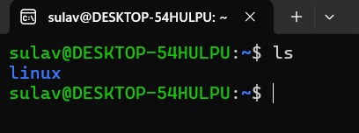

2. **Command: dir**

Interpretation: It is used to list information about the files (the current directory by default).

Output:

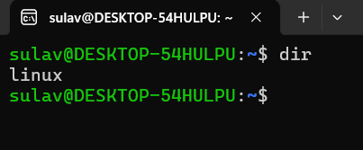

**3. Command: ls -a**

Interpretation: It is used to list contents of the current working directory where option -a is used for displaying all the contents of the directory along with entries starting with. (dot)

Output:



**4. Command: ls -l**

Interpretation: It is used to list contents of the current working directory where option -l is used for displaying contents of the directory with a long listing format

Output:

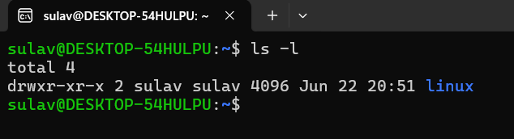

**5**. **Command: ls -lh**

Interpretation: It is used to list contents of the current working directory where option -lh is used for displaying contents of the directory with a long listing format with human understandable sizes like 1K 234M 2G etc.

Output:



**6. Command: ls -F**

Interpretation: It is used to list directory contents and indicate the type of each entry.

Output:

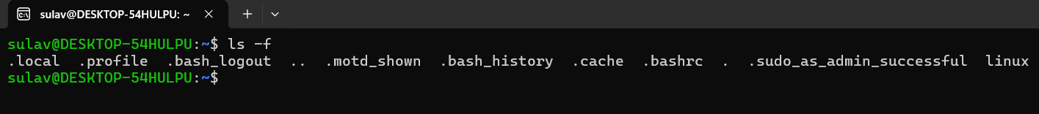

**7. Command: ls -r**

Interpretation: It is used to list the contents of directory in the reverse order while sorting

Output:

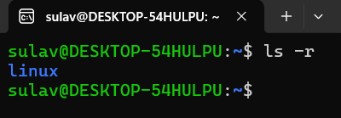

**8. Command: ls -R**

Interpretation: It is used to list the contents of the current working directory and subdirectories recursively

Output:

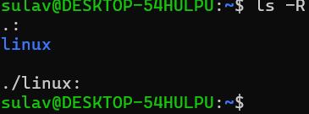

**9. Command: ls -ltr**

Interpretation: It is used to list the contents of the current working directory where -l displays in long listing format and -t sorts by time, (newest first) and -r reverse the order while listing So the content of the directory is listed in long listing format sorted by time(oldest first)

Output:

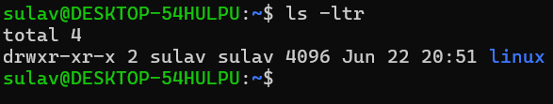

**10. Command: ls -i**

Interpretation: It is used to list the contents of directory with index numbers.

Output:

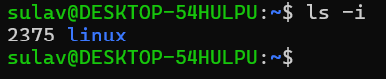

**11. Command: ls –version**

Interpretation: It Prints the version information of the program ls.

Output:

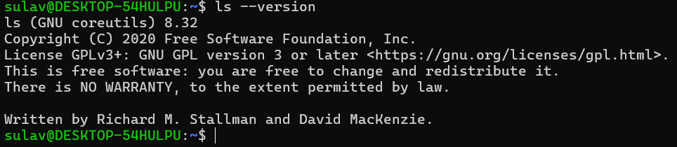

**12. Command: ls --help**

Interpretation: It displays the help guide of the program ls.

Output:

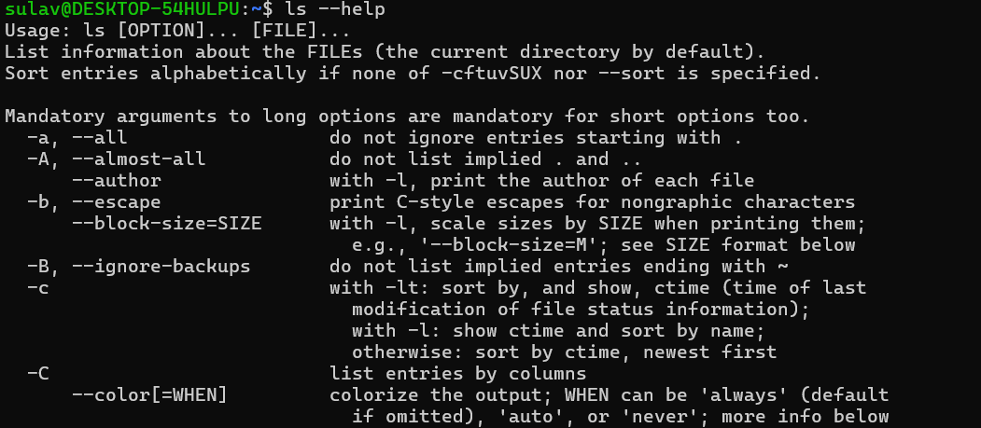

**13.** **Command: ls -n**

Interpretation: It lists the contents of directory with numeric users and group IDs.

Output:

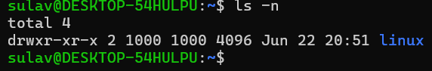

**14. Command: clear**

Interpretation: It is used to clear the terminal screen.

Output:

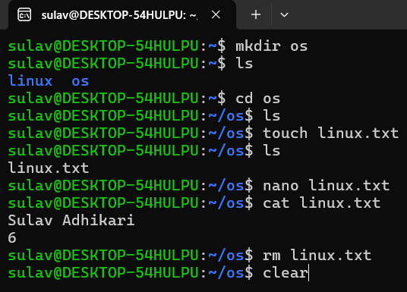

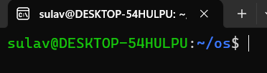

**15. Command: mkdir os**

Interpretation: It is used to make directories.

Output:

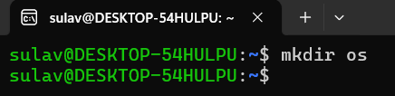

**16. Command: ls**

Interpretation: It is used to list the contents of the current working directory.

Output:

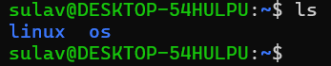

**17. Command: cd os**

Interpretation: It changes directory to os in terminal.

Output:



**18. Command: ls**

Interpretation: It is used to list the contents of the current working directory.

Output:



**19. Command: touch linux.txt**

Interpretation: It is used to create a file named linux.txt.

Output:



**20. Command: ls**

Interpretation: It is used to list the contents of the current working directory.

Output:

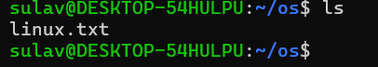

**21. Command: nano linux.txt**

Interpretation: It opens the file linux.txt in text editor nano.

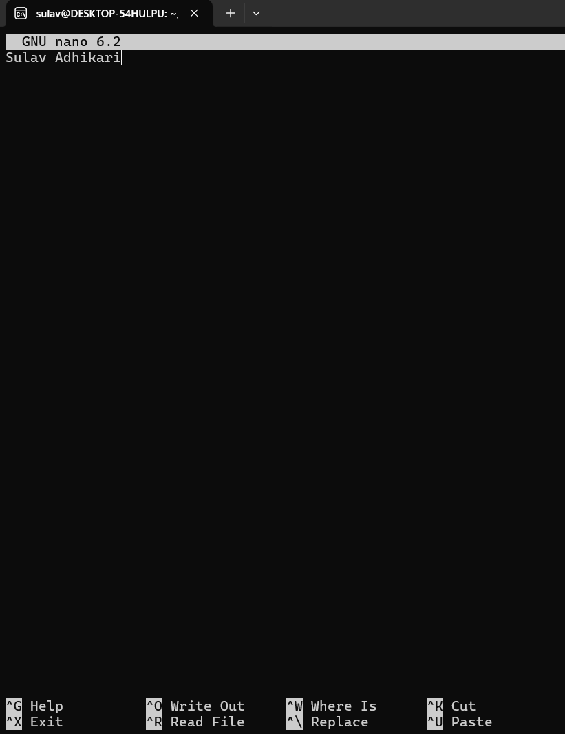Output:

**22. Command: cat linux.txt**

Interpretation: It displays content of linux.txt in the terminal.

Output:

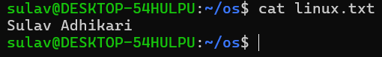

**23. Command: touch unix.txt**

Interpretation: It is used to create a file named unix.txt.

Output:



**24. Command: cat > unix.txt**

Interpretation: It allows user to display the text in the file unix.txt and is excited by CTRL+C.

Output:

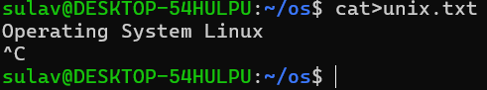

**25. Command: cat unix.txt**

Interpretation: It allows user to display the text in the file unix.txt

Output:

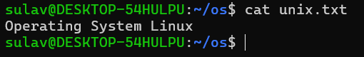

**26. Command: touch fedora.txt arch.txt debian.txt red_hat.txt**

Interpretation: It creates files named fedora.txt, arch.txt, debian.txt, red_hat.txt.

Output:



**27. Command: ls**

Interpretation: It is used to list the contents of the current working directory.

Output:



**28. Command: cp linux.txt fedora.txt**

Interpretation: It is used to copy the contents of file linux.txt into file fedora.txt.

Output:



**29. Command: cat fedora.txt**

Interpretation: It allows user to display the text in the file unix.txt.

Output:

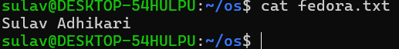

**30. Command: cd**

Interpretation: It allows user to change directory to one step back.

Output:



**31. Command: mkdir ubuntu**

Interpretation: It creates the directory named Ubuntu.

Output:



**32. Command: ls**

Output:

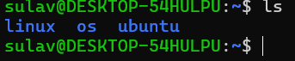

**33. Command: pwd**

Interpretation: It allows user to print name of current/working directory.

Output:

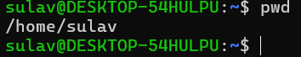

**34. Command: cp /home/sulav/os/fedora.txt /home/sulav/Ubuntu**

Interpretation: It copies the file from directory cp /home/sulav/os/fedora.txt to directory /home/sulav/UbuntuOutput:



**35. Command: ls /home/user/Ubuntu**

Interpretation: It lists the contents of directory cp/home/sulav/ubuntu.

Output:

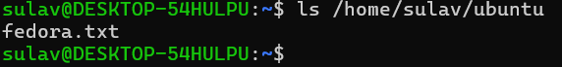

**36. Command: cat /home/user/ubuntu/fedora.txt**

Interpretation: It allows user to read the /home/sulav/ubuntu/fedora.txt and displays it in the terminal.

Output:



**37. Command: mv /home/user/os/debian.txt /home/user/ubuntu**

Interpretation: It allows user to move the file /home/sulav/os/debian.txt to directory /home/sulav/ubuntu.

Output



**38. Command: cd os**

Interpretation: It is used to open the directory named os.



**39. Command: ls**

Output:

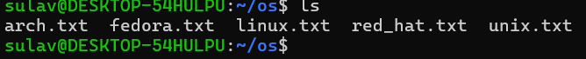

**40. Command: rm fedora.txt**

Interpretation: It deletes the file named fedora.txt.

Output:



**41. Command: ls**

Output:

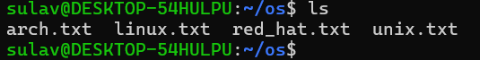

**42. Command: rm arch.txt linux.txt**

Interpretation: It deletes the file named arch.txt linux.txt from current working directory

Output:



**43. Command: ls**

Output:

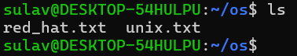

**44. Command: rm *.txt**

Interpretation: It deletes all the files whose name ends with .txt.

Output:



**45. Command: ls**

Output:



**46. Command: cd**

Interpretation: It is used to navigate between directories.

Output:



**47. Command: rmdir os**

Interpretation: It deletes the directory named os from current working directory.

Output:



**48. Command: ls**

Output:



**49. Command: rmdir Ubuntu**

Interpretation: It is used to delete the directory named ubuntu when the specified directory is empty

Output:



**50. Command: ls**

Output:

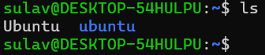

**51. Command: rm -rf Ubuntu**

Interpretation: It deletes the directory ubuntu and it’s content recursively and forcefully

Output:



**52. Command: ls**

Output:

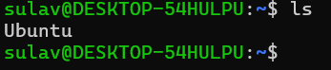

**Conclusion:**

In conclusion, this lab exercise provides a comprehensive introduction to fundamental Linux commands, equipping users with the skills necessary to perform basic file and directory management tasks. Through practical examples, users gain hands-on experience in navigating the Linux file system, manipulating files and directories, and using command options effectively. Mastery of these commands forms the backbone of Linux system administration, enabling users to efficiently interact with the operating system. This foundational knowledge is crucial for advancing to more complex tasks and optimizing workflow in a Linux environment. Ultimately, this exercise serves as a stepping stone toward proficient Linux command-line usage.